A202-STIA1123-EXERCISE 1-OOP

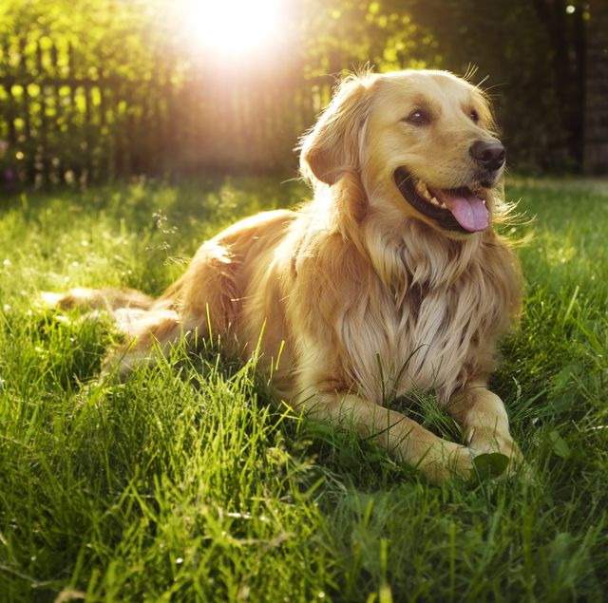1. Class: Dog

States: eye colour, breed, age  
Method: bark(), herd(), eat()

|  |
| --- |
| Dog |
| dogName: String  eyeColor: String  breed: String  dogAge: Int |
| changeName(): void  bark(): string  herd(): string eat(): string |

2. Class: Fruit

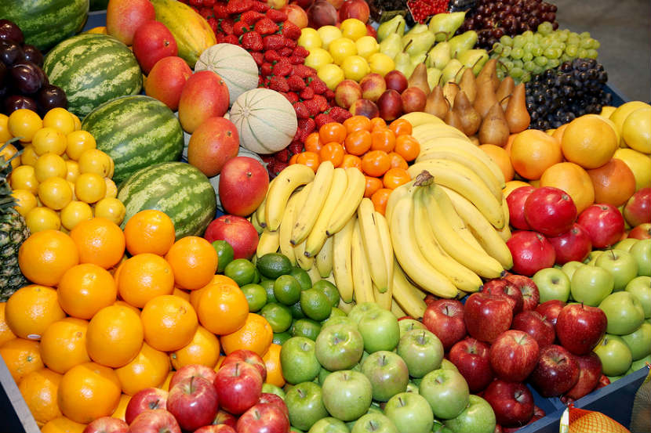

States: colour, taste, price

Instance: apple, orange, mango, banana

|  |
| --- |
| Fruits |
| colour: String  species: String  taste: String  price: int |
| updatePrice(): void  harvested(): void  processing(): void  preserving(): void |

3. Class: Laptop

States: model, processor, colour, storage, OS, display, price

Method: on(), off(), processing()

|  |
| --- |
| Laptop |
| model: String  processor: String  colour: String  storage: int  OS: String  Display: String  Price: int |
| on(): void  off(): void  delete(): void  volumeUp(): void  volumeDown(): void  loading(): void |

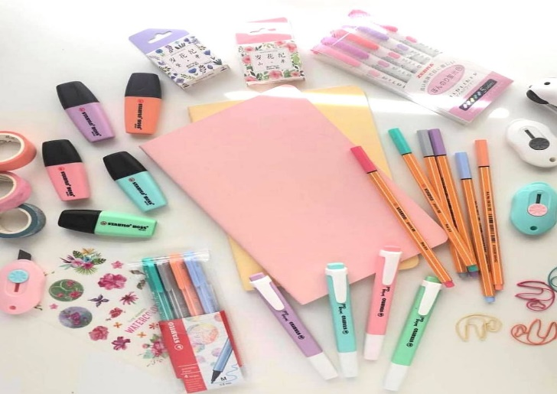4. Class: Stationery

States: colour, brand, size, price

Instance: pencil, marker pen, scissors, ruler

|  |
| --- |
| Stationery |
| colour: String  brand: String  size: String  price: int |
| write(): void  highlighted(): void  cut(): void |

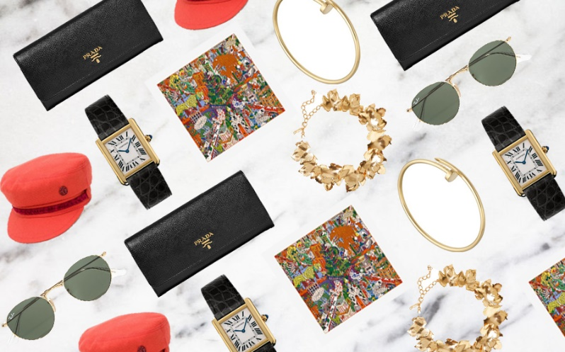5. Class: Accessories

States: material, size, colour, price

Instance: necklace, bracelet, watch, spectaculars, hat

|  |
| --- |
| Accessories |
| material: String  size: String  colour: String  price: int |
| wear(): void  buy(): void  sold(): void  tie(): void |